Chapter 7, Problem 49.

If the waveform in Fig. 7.116(a) is applied to the circuit of Fig. 7.116(b), find v(t). Assume v(0) = 0.

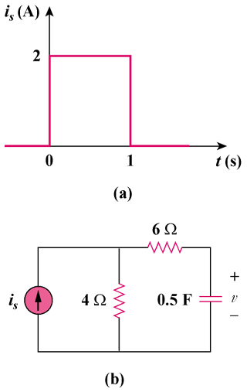

Figure 7.116
For Prob. 7.49.

